# ACS 560 Software Engineering

# Homework 10

# (Ashwini Kulkarni)

**(1) Database (SQLite)**

Data Inserted into CourseEvaluation

Screenshot

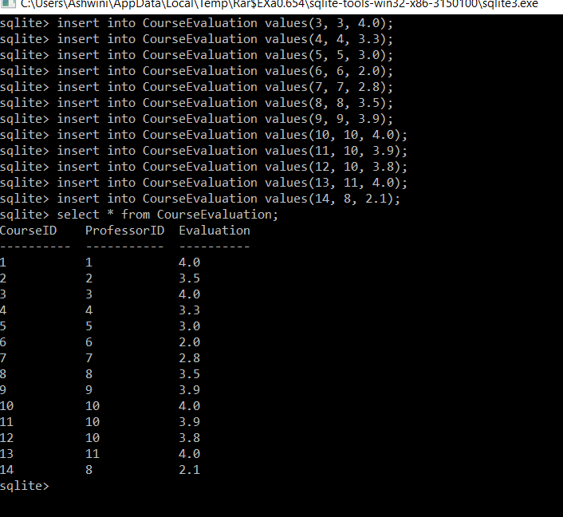

1. **Find a SQL to calculate the average of evaluation scores of all professors. Note that if a professor is teaching multiple courses, the evaluation score of this professor is the average of evaluation scores of all courses this professor is teaching. Please note the average of evaluation scores of all professors is different from the average of evaluation scores of all courses.**

Select ProfessorID, avg(Evaluation) as Avg_evaluation

From CourseEvaluation

Group by ProfessorID;

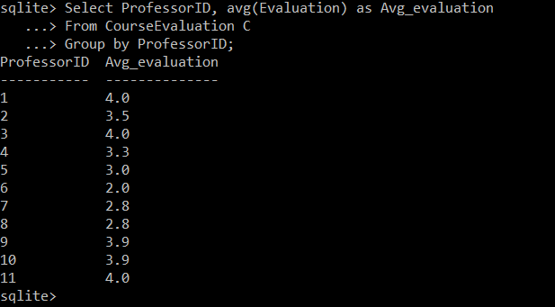

1. **Find a SQL to show the list of professors and the evaluation scores of the professors whose evaluation scores are greater than the average of evaluation scores of all professors.**

Select A.ProfessorID, A.Evaluation,B. Avg_evaluation

From CourseEvaluation A INNER JOIN

(Select ProfessorID, avg(Evaluation) as Avg_evaluation

From CourseEvaluation

Group by ProfessorID) B ON A. ProfessorID=B. ProfessorID

Where A. Evaluation>B. Avg_evaluation

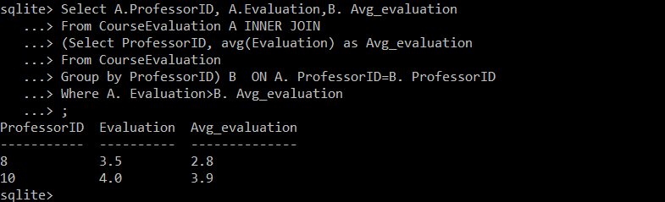

**(2) Database (SQLite)**

**Creating table in SQLite**

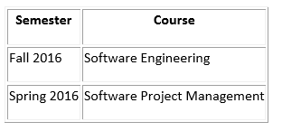

**Script: Project folder is submitted along with this document**

Output:-

